**MINITSRY OF EDUCATION AND TRAINING**

**UNIVERSE OF TECHNOLOGY AND EDUCATION**

**FACULTY OF HIGH QUALITY DEPARTMENT**

**-----------------⸙∆⸙-----------------**



**WEEK 5’S REPORT**

**Topic: Chapter 5’s report**

**Lecturer : Trần Đức Thiện**

**Name : Trần Minh Quân**

**ID : 19151078**

**Tp. Hồ Chí Minh ngày 21 tháng 03 năm 2022**

Contents

1. 74LS151

## Choosing different channel using button

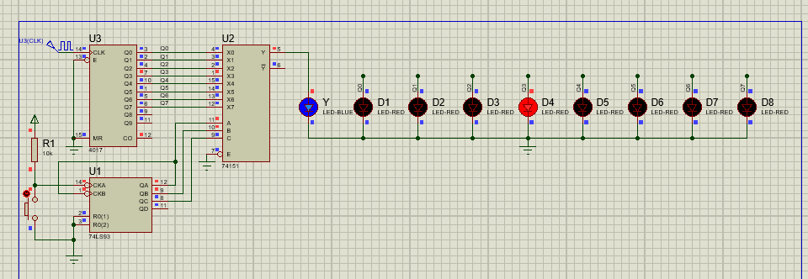

Figure : Choosing different channel using button

**Operation:** By pressing the button output Y pin of ic 74151 will equal to the corresponding input.

**Example:** Like in figure 1, after pressing the button 3 time the output Y will equal to X3.

## PWM with 8 different level

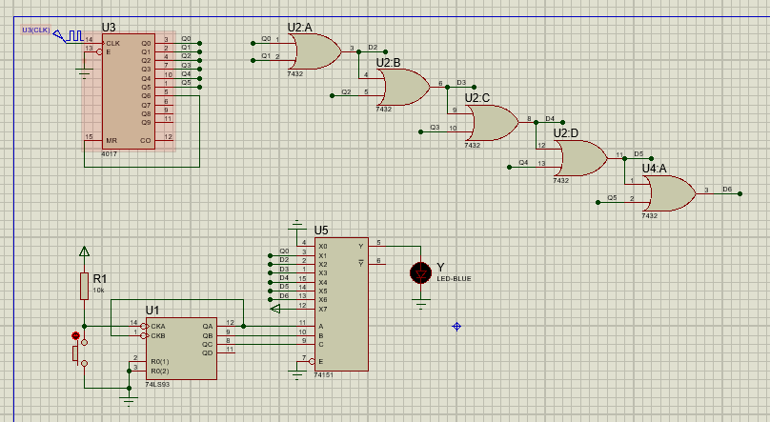

Figure : PWM with button to control LED

Operational: This circuit provide 8 different level of lighting of the LED where,

* When press the button 0 time:

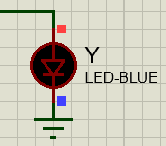

Figure : LED is on but not visibly

* When press the button 2 time:

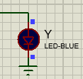

Figure : LED is on level 2

* When press the button 3 times:

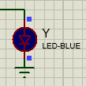

Figure : LED is on level 3

* When press the button 4 times:

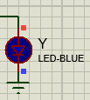

Figure : LED is on level 4

* When press the button 5 times:

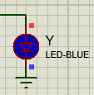

Figure : LED is on level 5

* When press the button 6 times:

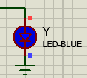

Figure : LED is on level 6

* When press the button 7 times:

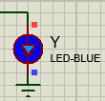

Figure : LED is on maxmimum effect